Generation Z
In recent years, many people have claimed that “Generation Z” (those born in 1994-2004) are lazy, unaware, and apathetic.

On the website huffingtonpost.com, Juliana Micoleta writes, “Gen Z is often portrayed as less engaged in politics; they have short attention spans and don’t care about the weighty issues that confront their generation and the nation; and they're more interested in technology and celebrity than staying active in their communities and schools.”

Printed Books and Generation Z
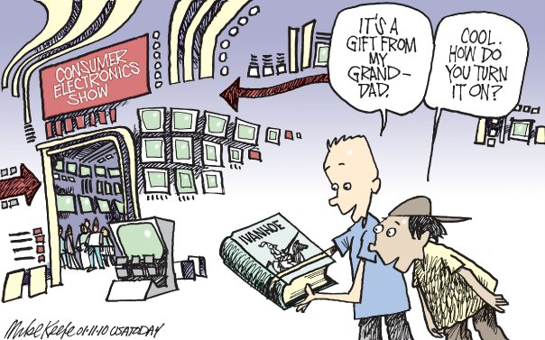
Does the editorial cartoon above support or refute Micoleta’s comments? Why?

Generation Z Response
Do you agree or disagree with Juliana Micoleta and her comments about Generation Z? Choose a Generation Z piece (song, poem, story, article, movie, documentary, film or public figure/celebrity) as evidence to support or refute Micoleta’s comments.

Before you write your response, think about the following questions:
- How does your piece reflect the unique values or principles of Generation Z?
- How does your selected piece reflect a gender or ethnic perspective?
- Does this perspective leave a positive or negative imprint on society?

When you write your response, discuss the author’s argument or rhetorical devices (or lack thereof) to prove your position.

____________________________________________________________________________________________________________________________________________________________________________________________________________________________________________________________________________________________________________________________________________________________________________________________________________________________________________________________________________________________________________________________________________________________________________________________________________________________________________________________________________________________________________________________________________________________________________________________________________

